(Approx. 430 words)

How to find Twitter’s hidden options
By Linda Gonse, Editor/Webmaster, ORCOPUG (Orange County PCUG), California
April 2012 issue, Nibbles ‘n Bits
www.orcopug.org
editor (at) orcopug.org

More people are using the Twitter social networking site and finding out that they like the mini-blog that allows them 140 characters to say whatever they want to say. But, there is more to Twitter than tweeting (posting a comment).

A new Twitter user might not realize there are options that are hidden, unless a user knows how to find them hiding in plain sight.

For instance, hovering over a tweet will reveal links that might not be found anywhere else.

What’s more, depending on the type of tweet the hidden options will be different.
For instance, if I am just looking at my tweet on the page and not hovering the cursor over it, I only see the time or date when it was written in the upper right-hand corner.



If I hover my cursor over the tweet, however, hyperlinked options — Reply, Delete, Favorite, Open — appear on the same line as my name at the top of the tweet, but in the right corner in green text.

I can click on Reply to the person who posted the tweet. I can Delete the tweet. This option is only available to the person whose tweet is posted. In other words, only I will see the Delete link for my tweets. And, only I can delete my tweets. I can mark it as a Favorite—it won’t be cycled out of my timeline, but parked in a permanent area on my Profile page for favorite tweets when I want to reference it again. Finally, I can Open the tweet to read replies that others have had to this specific tweet.

If I hover my cursor over someone else’s tweet the options are Reply, Retweet, Favorite, and Open. There’s no Delete.

Clicking on the Open hyperlink allows the tweet to expand when other tweets are associated with it. The expanded tweet will also reveal if other people have favorited your tweet or retweeted it.

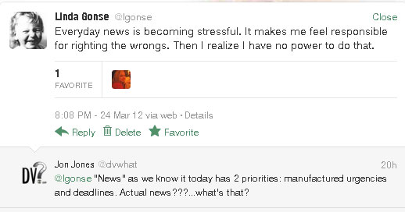

This is a recent innovation at Twitter. It is now possible to view your tweets in a thread, including replies to another person in their open threads. It is very convenient to view the conversations that are revealed, because there may be several hours, or sometimes days, between a tweet being posted and replies to it.

The Open link automatically changes to a Close link. You can collapse all the tweets again, except the original tweet, when you have finished reading them.

